Mrs. Sturgis
Email: ksturgis@newpaltz.k12.ny.us
Welcome to 6th Grade Art….

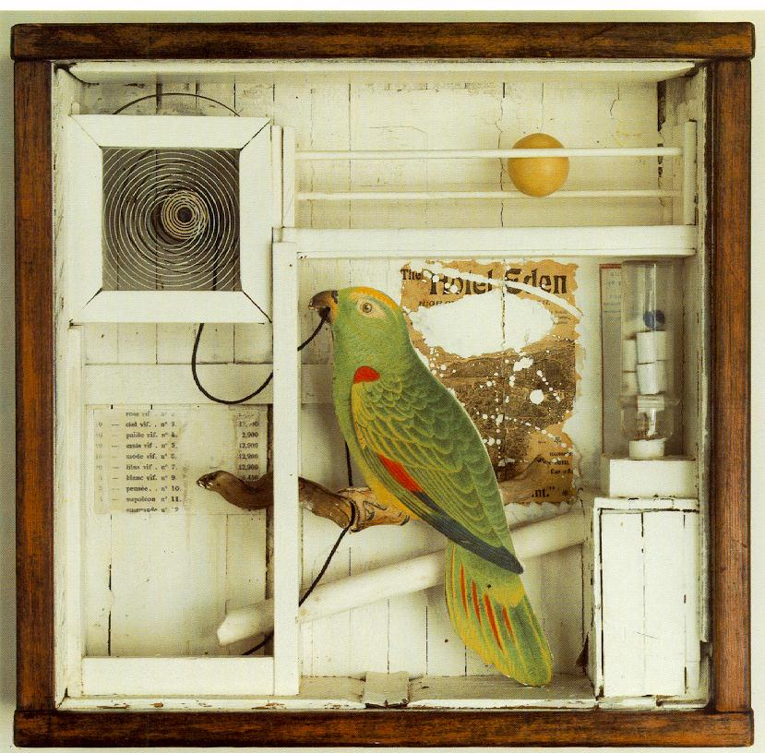
Untitled (The Hotel Eden) Joseph Cornell 1945
Goals:
- To use art as a personal means of expression.
- To focus on art as a vehicle to translate ideas into artwork.
- To create art using variety of media and techniques
- To analyze and interpret works of art
- To develop your own artistic aesthetic

Topics to be explored:
Students will use art to explore ideas about themselves and the world they live in. Our goal is for students to make a personal connection to the art they create, addressing topics such a personality traits, friendships, family, relationships and peer interactions.

Planned Projects for the current school year:
- Name Project
- Self-Portrait Collage
- Memory Box
- Personal Adornment
- Art for your own environment
- School/Community Project
- Art to Share/Artist Trading cards

Grades:
Grades for each project will be based on a point system. Project
Rubrics are based on the following categories:
- Elements of Art and Principles of Design as they relate to each
Individual project
- Creativity
- Effort
- Craftsmanship

Each project will have a specifically designed rubric with clear expectations.
Class effort is the most influential factor in each one of these categories.

